Task 1

INCLUDE Irvine32.inc

.data

array word 10 dup(?)

.code

main PROC

mov eax,10

call dumpregs

mov ecx,10

mov esi,0

li:

push eax

dec eax

; call writeint

call crlf

loop li

mov ecx,10

l2:

pop eax

mov array[esi],ax

add esi,2

loop l2

mov ecx,10

mov esi,0

l3:

mov ax,array[esi]

add esi,2

call writedec

call crlf

loop l3

exit

main ENDP

END main

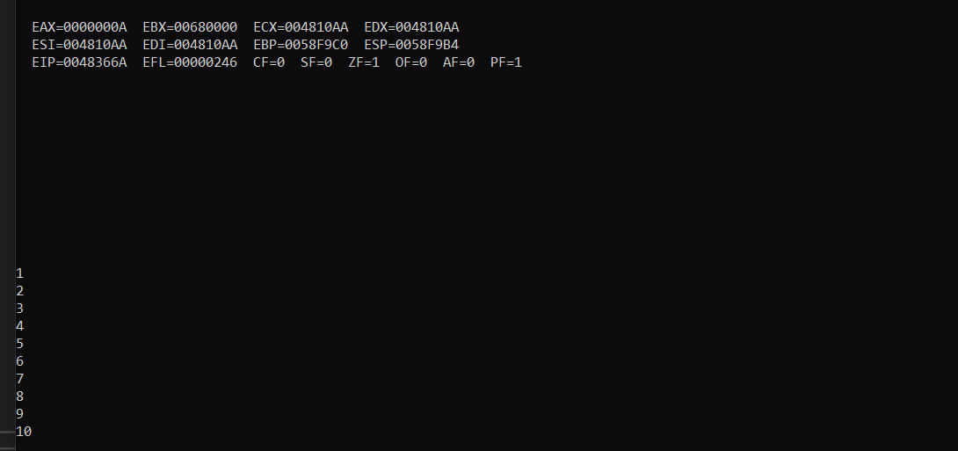

Task 2

INCLUDE Irvine32.inc

.data

.code

main PROC

mov eax,0

mov ebx,0

call dumpregs

push 5

push 6

push 7

mov ecx,3

l:

pop eax

add ebx,eax

loop l

call dumpregs

exit

main ENDP

END main

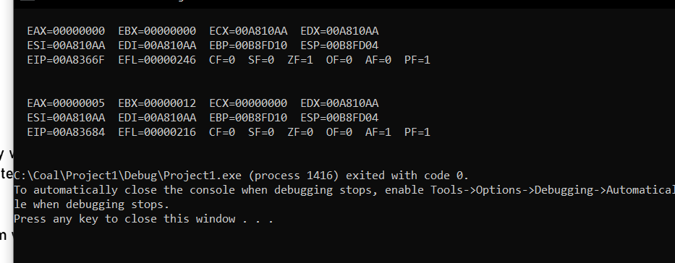

Task 4

INCLUDE Irvine32.inc

.data

msg byte "Enter the Number: ",0

.code

main PROC

mov ebx,0

mov edx,offset msg

call writestring

call readint

call crlf

mov ecx,eax

mov eax,1

l:

add ebx,eax

inc eax

loop l

call dumpregs

exit

main ENDP

END main

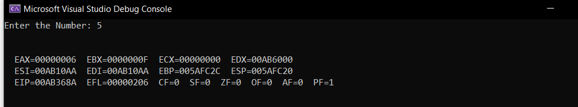

Task 3

INCLUDE Irvine32.inc

.data

arr1 word 1,2,3,4,5

arr2 word 6,7,8,9,10

.code

main PROC

mov eax,0

mov ebx,0

call dumpregs

call fun1

exit

main ENDP

;fun 1

fun1 PROC

mov esi, offset arr1

mov ecx,5

mov eax,0

mov ebx,0

l1:

add ax,[esi+ebx\*2]

inc ebx

loop l1

call fun2

ret

fun1 ENDP

;fun 2

fun2 PROC

mov esi, offset arr2

mov ecx,5

mov eax,0

mov ebx,0

l1:

add dx,[esi+ebx\*2]

inc ebx

loop l1

call addd

ret

fun2 ENDP

; fun 3

addd PROC

add eax,[edx]

call writeint

call crlf

ret

addd ENDP

END main

